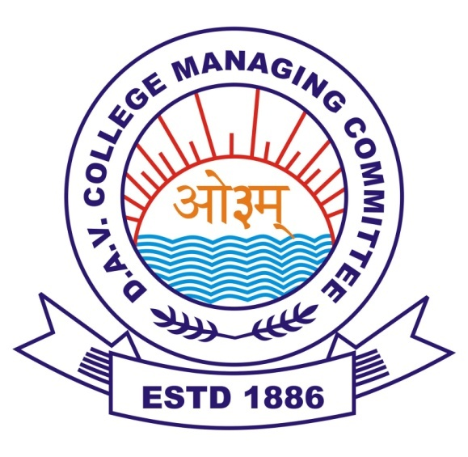

**CL DAV PUBLIC SCHOOL**  
 **SUBJECT** – CHEMISTRY

**TOPIC** – DYEING OF FABRICS

**EXPERIMENT** – **TO DYE WOOL AND COTTON CLOTHES**

**WITH MALACHITE GREEN**

**SUBMITTED BY** : ADITYA

CLASS : XII – B

ROLL NO. -